Review
Aaron Niecestro
January 31, 2017
review<-read.csv("/home/an248493/Review.csv")
Histograms below ...
histogram(~GN6,data=review)
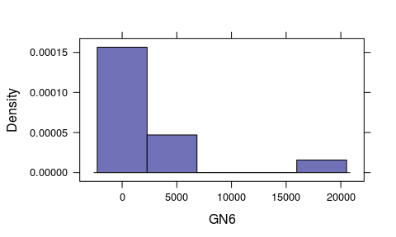
histogram(~GP6,data=review)
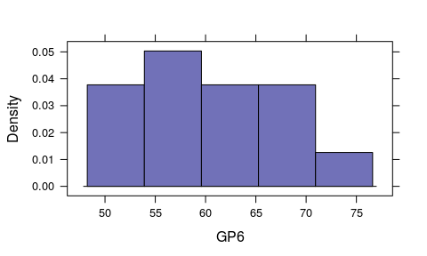
histogram(~AN6,data=review)
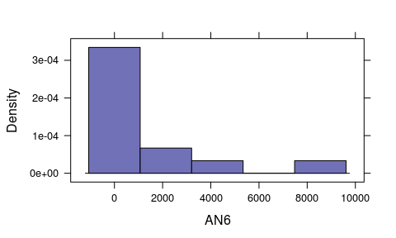
histogram(~AP6,data=review)
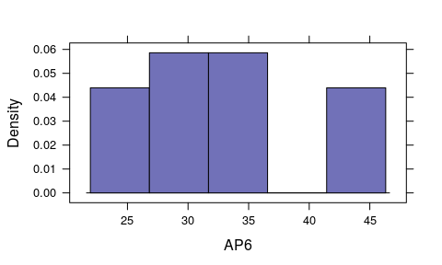
histogram(~DKN6,data=review)
## Warning in mean.default(x, na.rm = TRUE): argument is not numeric or
## logical: returning NA
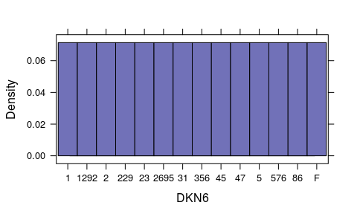
histogram(~DKP6,data=review)
## Warning in mean.default(x, na.rm = TRUE): argument is not numeric or
## logical: returning NA
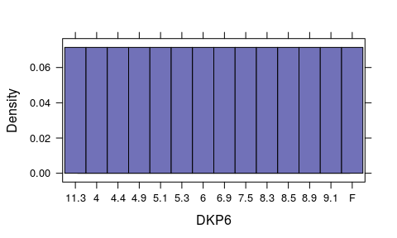
histogram(~GN5,data=review)
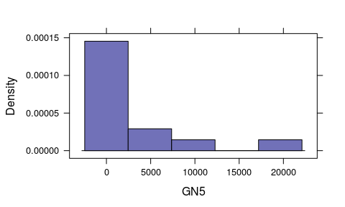
histogram(~GP5,data=review)
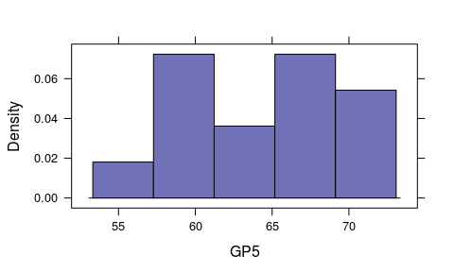
histogram(~AN5,data=review)
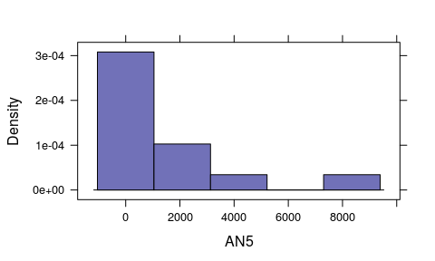
histogram(~AP5,data=review)
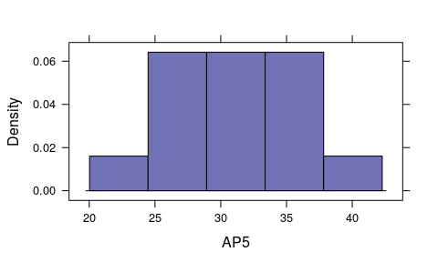
histogram(~DKN5,data=review)
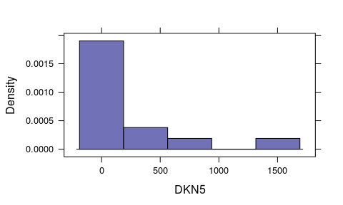
histogram(~DKP5,data=review)
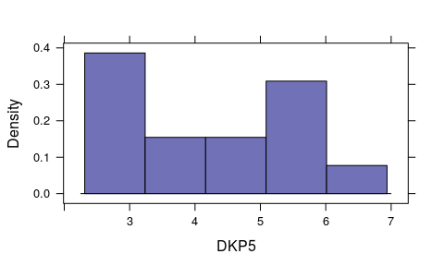
histogram(~GN4,data=review)
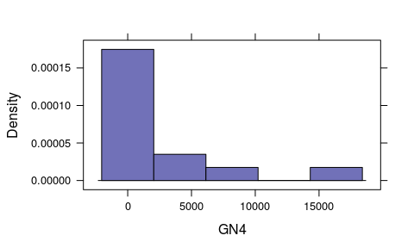
histogram(~GP4,data=review)
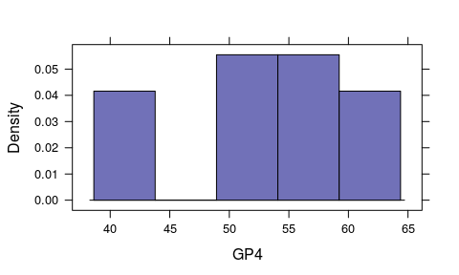
histogram(~AN4,data=review)
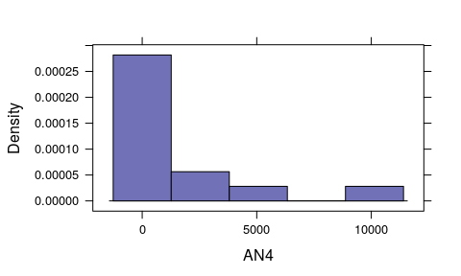
histogram(~AP4,data=review)
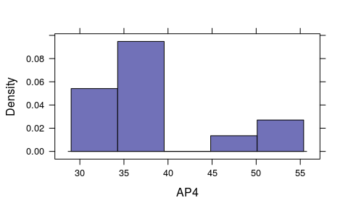
histogram(~DKN4,data=review)
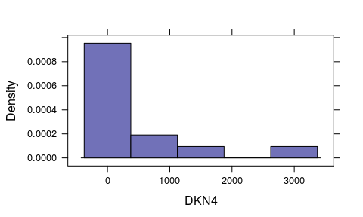
histogram(~DKP4,data=review)
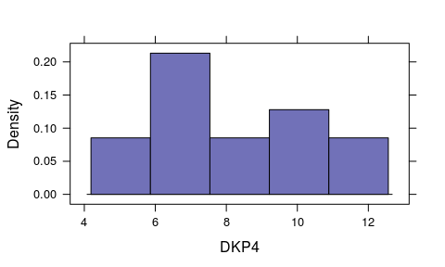
histogram(~GN3,data=review)
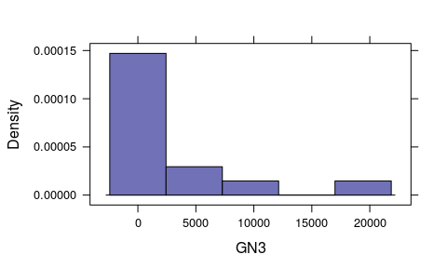
histogram(~GP3,data=review)
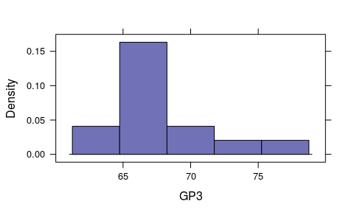
histogram(~AN3,data=review)
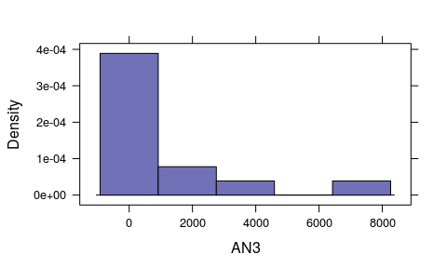
histogram(~AP3,data=review)
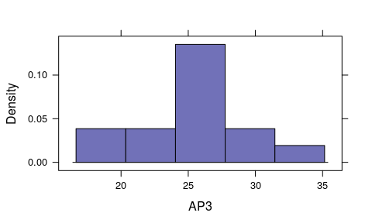
histogram(~DKN3,data=review)
## Warning in mean.default(x, na.rm = TRUE): argument is not numeric or
## logical: returning NA
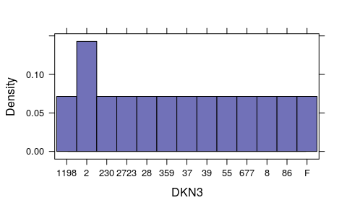
histogram(~DKP3,data=review)
## Warning in mean.default(x, na.rm = TRUE): argument is not numeric or
## logical: returning NA
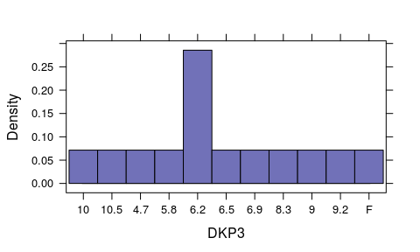
histogram(~GN2,data=review)
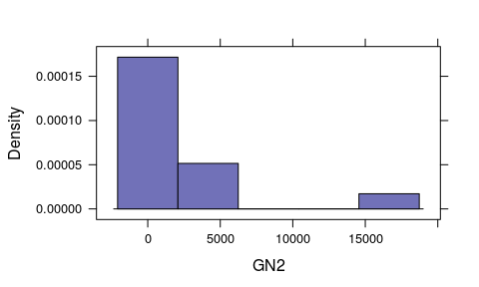
histogram(~GP2,data=review)
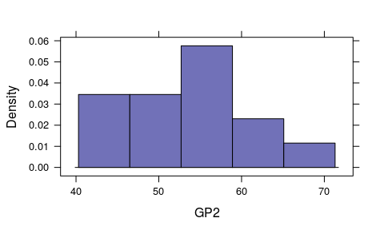
histogram(~AN2,data=review)
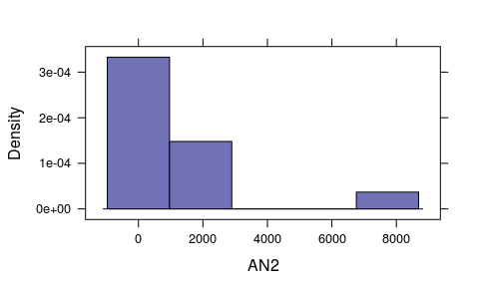
histogram(~AP2,data=review)
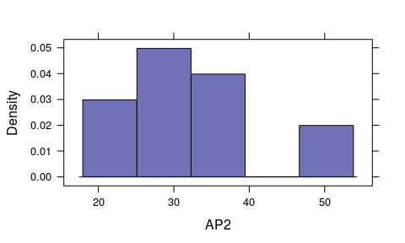
histogram(~DKN2,data=review)
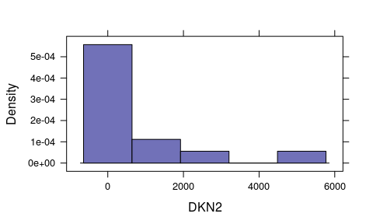
histogram(~DKP2,data=review)
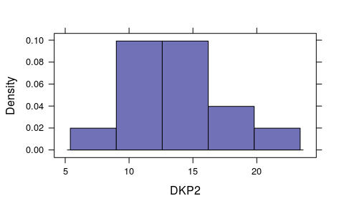
histogram(~GN1,data=review)
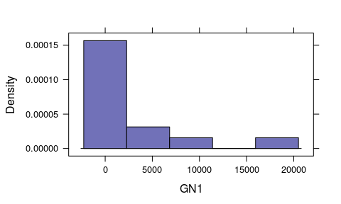
histogram(~GP1,data=review)
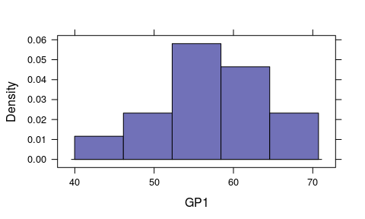
histogram(~AN1,data=review)
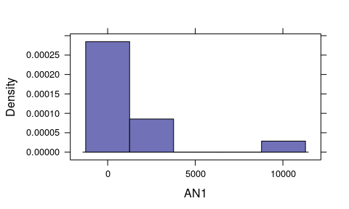
histogram(~AP1,data=review)
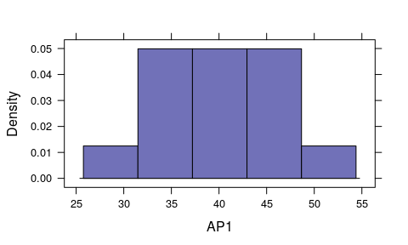
histogram(~DKN1,data=review)
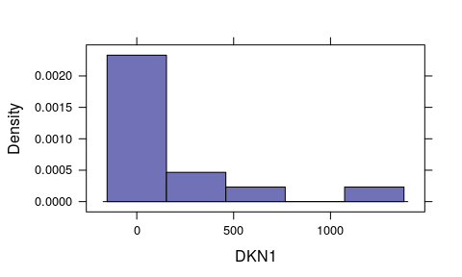
histogram(~DKP1,data=review)
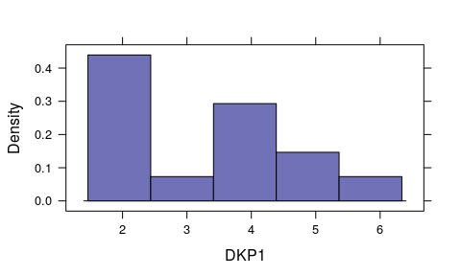
Boxplots below ...
bwplot(~GN6,data=review)
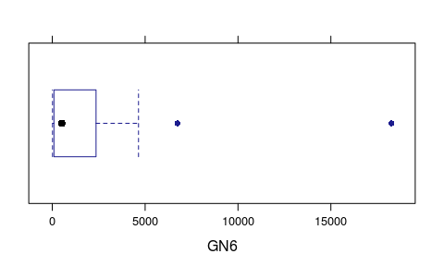
bwplot(~GP6,data=review)
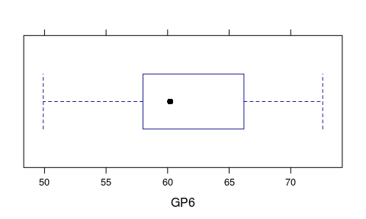
bwplot(~AN6,data=review)
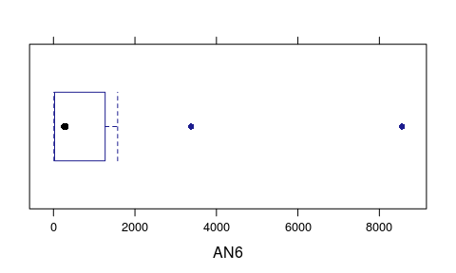
bwplot(~AP6,data=review)
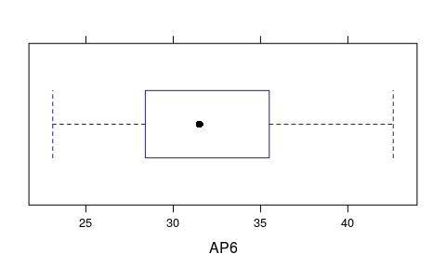
bwplot(~DKN6,data=review)
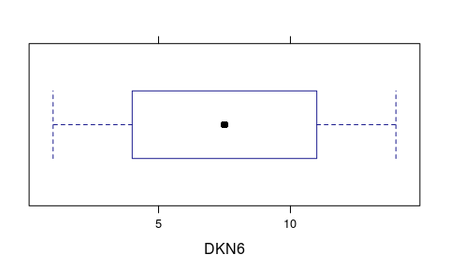
bwplot(~DKP6,data=review)
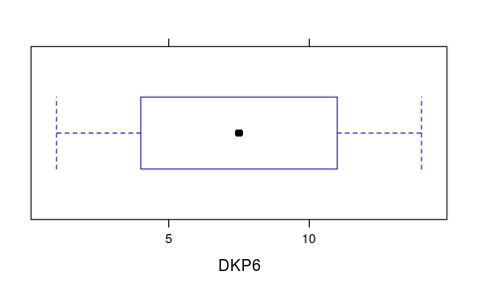
bwplot(~GN5,data=review)
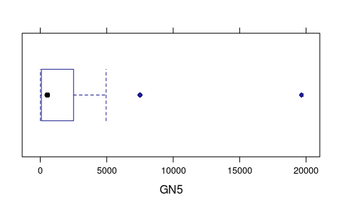
bwplot(~GP5,data=review)
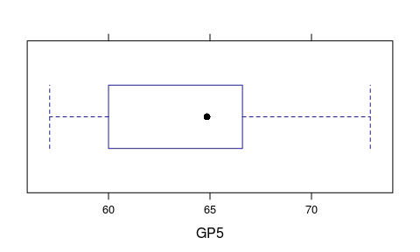
bwplot(~AN5,data=review)
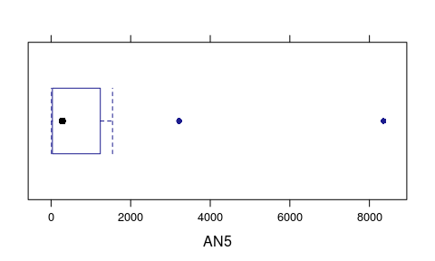
bwplot(~AP5,data=review)
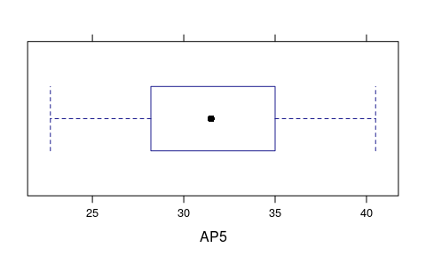
bwplot(~DKN5,data=review)
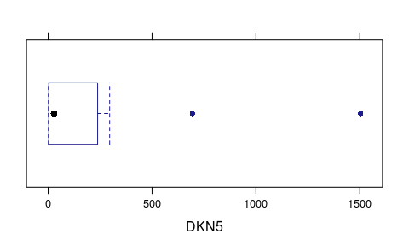
bwplot(~DKP5,data=review)
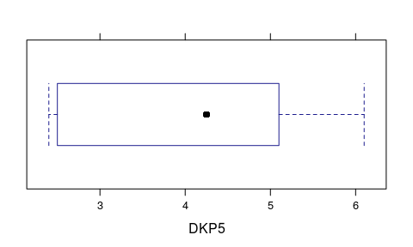
bwplot(~GN4,data=review)
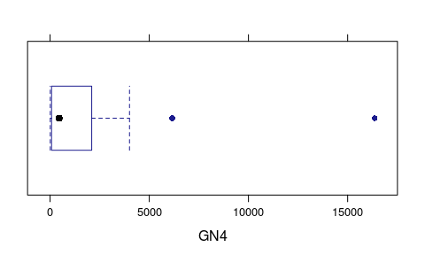
bwplot(~GP4,data=review)
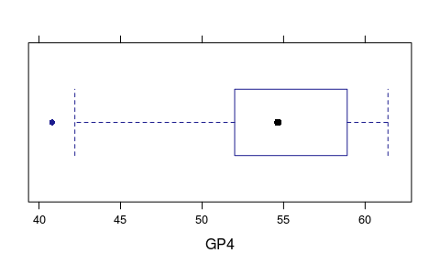
bwplot(~AN4,data=review)
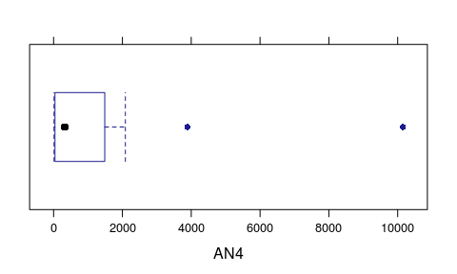
bwplot(~AP4,data=review)
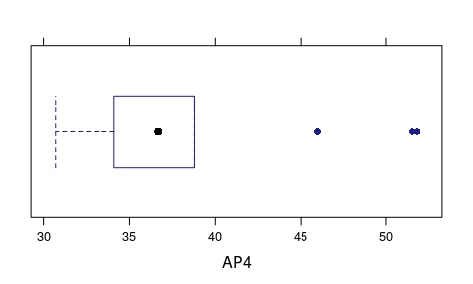
bwplot(~DKN4,data=review)
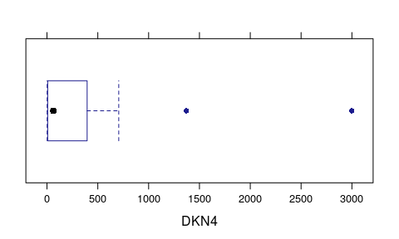
bwplot(~DKP4,data=review)
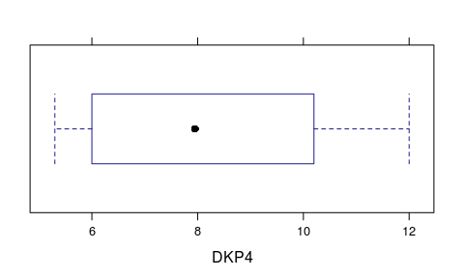
bwplot(~GN3,data=review)
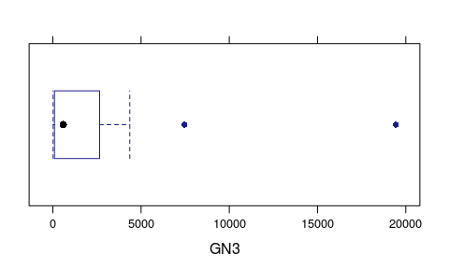
bwplot(~GP3,data=review)
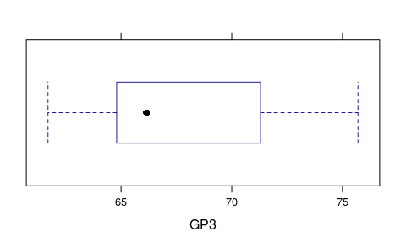
bwplot(~AN3,data=review)
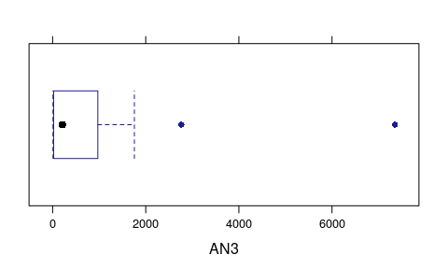
bwplot(~AP3,data=review)
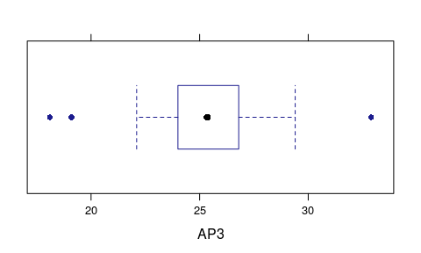
bwplot(~DKN3,data=review)
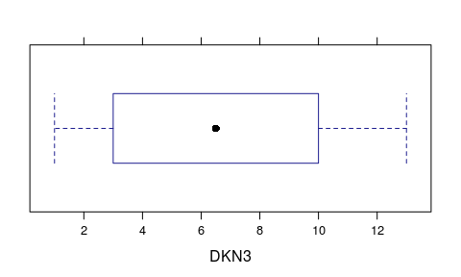
bwplot(~DKP3,data=review)
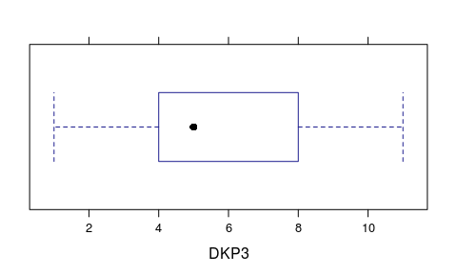
bwplot(~GN2,data=review)
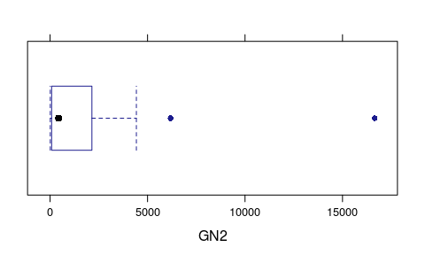
bwplot(~GP2,data=review)
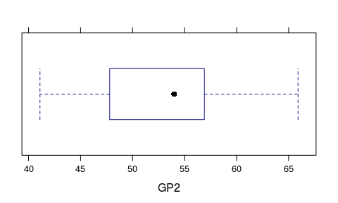
bwplot(~AN2,data=review)
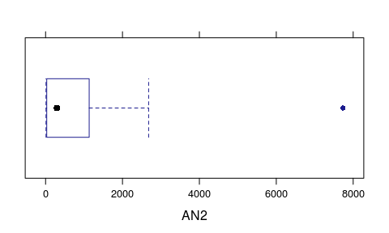
bwplot(~AP2,data=review)
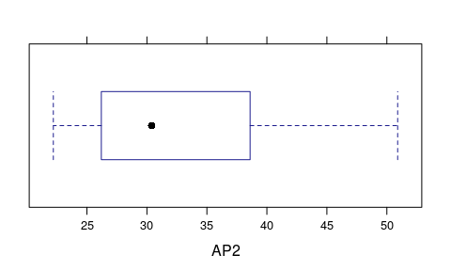
bwplot(~DKN2,data=review)
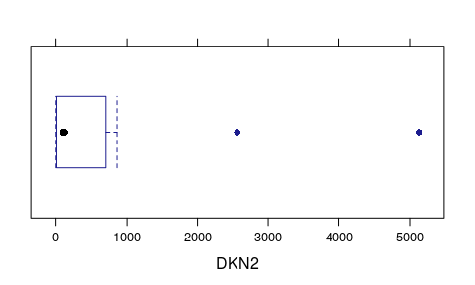
bwplot(~DKP2,data=review)
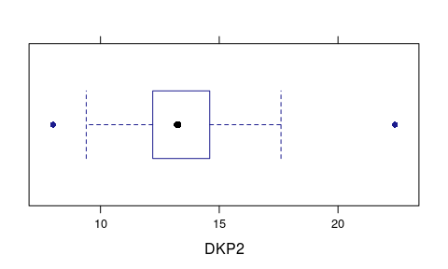
bwplot(~GN1,data=review)
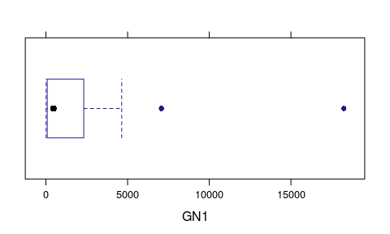
bwplot(~GP1,data=review)
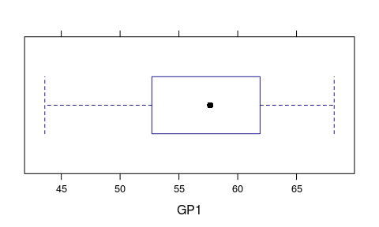
bwplot(~AN1,data=review)
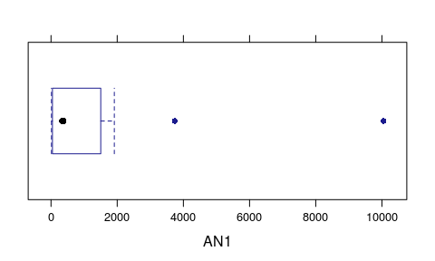
bwplot(~AP1,data=review)
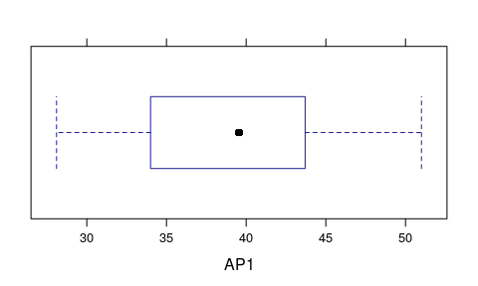
bwplot(~DKN1,data=review)
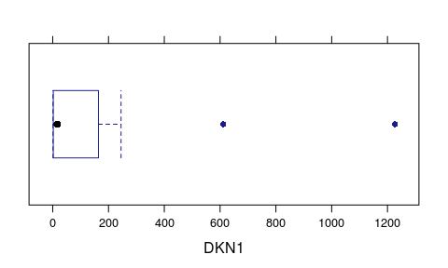
bwplot(~DKP1,data=review)
